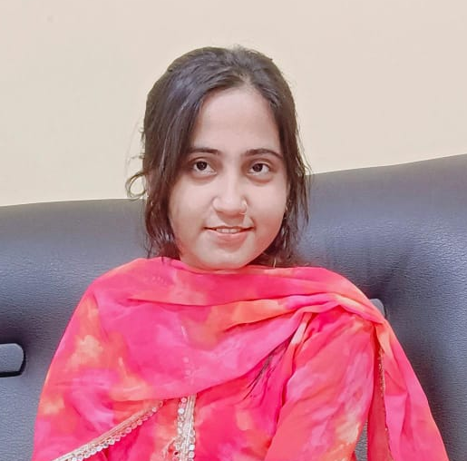
Sakshi Kumari
Patna, Bihar
Phone: 9102878009 | Email: sakshikumari0852@gmail.com

Objective
Motivated and dedicated professional seeking a dynamic role where I can leverage my communication and customer service skills while continuing to grow professionally and personally. Currently pursuing an MBA to enhance my business and management knowledge.

Education

Patliputra University, Patna
Graduation (BA Hons) – 60.62% | 2023

Bihar School Examination Board, Patna
Intermediate – 51.6% | 2020
10th – 47.4% | 2018

Currently Pursuing:
Honors Political Science – LPU | Expected Completion: 2026

Work Experience

Senior Admission Counselor: Vaishali Education Truest | 3 years

- Provided guidance to students and parents regarding admission processes and course selection.
- Assisted in the enrollment process and ensured all necessary documentation was completed.
- Developed strong relationships with prospective students and helped them make informed decisions.
- Achieved and exceeded admission targets by implementing effective counseling strategies.
- Coordinated with the marketing team to enhance outreach programs and student engagement.

Telecaller : Aadhnyayan Foundation | 2+ Years

- Handling inbound and outbound calls to assist customers with queries and provide information about products/services.
- Maintaining customer records and ensuring effective follow-up.
- Building strong relationships with clients to improve customer satisfaction.
- Meeting daily and monthly sales or customer service targets.
- Collaborating with the team to enhance overall performance and achieve company goals.

Social Media Management : Digital Sankalan | 6+ Months

- Managed social media platforms including Facebook, Instagram, and LinkedIn.
- Created engaging posts, captions, and short video content to increase audience reach.
- Planned and executed monthly content calendars for consistent posting.
- Monitored analytics to track engagement, impressions, and follower growth.
- Ran basic promotional campaigns to improve brand visibility.
- Responded to comments and messages to maintain positive audience interaction.
- Coordinated with the design and marketing team for creatives and campaigns.
- Increased page engagement through hashtag strategy, reels, and trending content.

Skill
- Leadership
- Creative Thinking
- Time Management
- Good Communication
- Customer Relationship Management
- Problem-Solving
- Multitasking

Interests
- Cooking
- Book Reading
- Social Work

Languages
- Hindi (Fluent)
- English (Proficient)

Declaration
I hereby declare that all the information provided above is true and correct to the best of my knowledge.

